UNIVERSITY OF VERMONT
STUDENT GOVERNMENT ASSOCIATION
RESOLUTION
Senate Bill No.: R.S.1 Date Submitted: 02-13-23
Date Introduced: 02-7-23
Introduced By: Senator Bourgault Date Action Taken: 02-14-23

Sponsored: Certified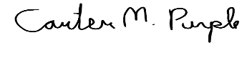 Senator Bourgault Speaker of the Senate Purple
Signed: 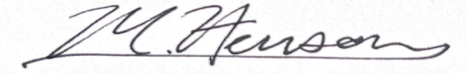 President Henson

Resolution Supporting Faculty Efforts to Democratize the UVM Board of Trustees

WHEREAS, the Student Government Association at the University of Vermont (henceforward referred to as UVM) recognizes “shared governance” as a system where different UVM stakeholders, including students, community members, legislators, and UVM faculty, are represented in the governance of the University on the UVM Board of Trustees,

WHEREAS, the Board of Trustees at UVM currently includes Self Perpetuating trustees, Legislative Trustees, Trustees appointed by the Governor of Vermont, Student Trustees, the Governor of Vermont, and the President of UVM; but UVM faculty are not represented,

LET IT BE KNOWN, that in 2022 the UVM Faculty Senate voted 96% in favor of shared governance for the UVM Board of Trustees, and that UVM faculty are actively seeking representation on the Board the Vermont State Legislature, Faculty representation on the Board will be achieved through a bill introduced in the Vermont House of Representatives and the Vermont Senate which would add two faculty with full voting rights to the UVM board of trustees, elected by the UVM Faculty Senate,

LET IT BE KNOWN, universities across the country are adopting shared governance of their Boards of Trustees as a superior method of governance that ensures decisions are made with the input of stakeholders who are both affected by and knowledgeable about those decisions,

LET IT BE KNOWN, shared governance will have a positive impact on the Faculty of UVM by improving morale, transparency, and diversity; and these benefits will therefore be conferred on UVM’s student body,

BE IT RESOLVED, the Student Government Association fully supports UVM Faculty efforts to democratize UVM’s Board of Trustees and implement shared governance at UVM that includes faculty perspectives, and supports the passage of bills in the Vermont House of Representatives and State Senate pursuant to those goals.

BE IT FURTHER RESOLVED, that the Student Government Association will encourage students to support this legislative initiative by contacting their state representatives and state senators.

